Heage Primary School
Information Report for children with Special Educational Needs and Disabilities (SEND)

Welcome
Contents
1 | What are Special Educational Needs (SEND) or a disability?
2 | Catering for different kinds of SEND
3 | How does our school know if pupils need extra help?  Identifying pupils with SEND
4 | Our School’s approach to teaching and supporting pupils with SEND
5 | How we consult and involve our pupils and parents/carers
6 | Outside agencies who might provide additional support
7 | How can I let the school know I am concerned about my child’s progress in school?
8 | How will the school let me know if they have any concerns about my child’s learning in school?
9 | Adaptations to the curriculum and accessibility
10 | Enabling pupils with SEND to engage in activities available to those in the school who do not have SEND
11 | How we support children with their emotional and social development
12 | How will school evaluate the effectiveness of the SEND provision?
13 | Supporting pupils moving between phases and preparing for adulthood
14 | What support do we have for you as a Parent/Carer of a child with SEN and/or disability?
15 | How does the Governing Board support SEND children and their families?
16 | Who are our key staff and what expertise do they have?
17 | Complaints about SEND provision
18 | The Local Offer
19 | Named contacts
20 | Glossary

Welcome

Please also refer to our SEND Policy which is available on our website.

Heage Primary School is supported by Derbyshire County Council to ensure that all pupils, regardless of their specific needs, make the best possible progress in school.

Our vision is to create a nurturing and inclusive environment where every child is respected, valued, and empowered to reach their full potential. We are committed to fostering a community built on the core values of respect, kindness, honesty, compassion, teamwork, and resilience.

'Grow with Kindness, Learn with Passion, Aspire to Be Your Best'

If you require access to this document or to our SEND policy in a different format, please contact the school office.

- What are Special Educational Needs (SEND) or a disability?
A pupil is defined as having SEND if they have:

- A significantly greater difficulty in learning than most others of the same age.
- A disability or health condition that prevents or hinders them from making use of educational facilities used by peers of the same age in mainstream settings.
- Special educational provision that is additional to or different from that made generally for other children or young people of the same age by mainstream settings.

A child who has an Individual Education Plan (IEP) and receives support which is different to and additional from everyday general practice and/or receives support from outside agencies is placed on our SEND list. This may be temporary or long term. Children can be added or removed from the list at any time. We are required to keep a list of children and their area of need for monitoring.

- Catering for different kinds of SEND

The Special educational Needs Code of practice (2014) outlines four broad areas of need:

Communication and Interaction
- Children with a speech, language and communication need. This
includes social communication need.
- Children who may have a speech delay, stammer or stutter.
- Selective mutism.
- Children who have Autism Spectrum Disorder with difficulties in
social communication.

Cognition and Learning
- Support for a wide range of learning difficulties including MLD
(moderate learning difficulty) or SLD (severe learning difficulty).

Social, Mental and Emotional Health (SMEH)
- Support for children who are withdrawn, isolated, displaying challenging disruptive behaviour.
- Anxiety, depression (including physical symptoms)

Sensory and/or physical
- Supporting children’s sensory needs
- Children with visual impairment / hearing impairment
- Fine / Gross motor including hypermobility and other physical disability

- How does our school know if pupils need extra help?
Identifying pupils with SEND
- Parents/Carers may inform the school prior to, during admission or at any point during their child’s time with us.
- Outside agencies may contact the school prior to or during admission or
whilst the child is a pupil at the school.
- A pupil’s previous pre-school/school might pass on concerns.
- Class teachers may identify concerns including progress or behaviours
- Class teachers make regular assessments of the progress of all children. From this the school is able to identify children who are making less than expected progress given their age and personal circumstances.
- Results from standardised tests
- Observation of the pupil may indicate concerns.
- Concerns raised by the pupil themselves

The SENDCO may suggest targeted teaching, such as small group work or special programmes to help the child. If a child’s needs persist, the SENDCO will set up an informal meeting to discuss this and next steps with Parents/Carers in more detail.
Next steps might include:
- Agreeing an IEP and following the assess, plan, do, review cycle as described below in section 4
- Being placed on the SEN list
- Referrals to outside agencies (if appropriate)

- Our school’s approach to teaching and supporting pupils with SEND
- Teachers are responsible and accountable for the progress and development of all the pupils in their class.
- Most children will have their learning needs met through quality first teaching.
- Class Teachers plan lessons according to the specific needs of all groups of children in their class and will ensure that learning tasks are adapted in order to enable your child to access their learning as independently as possible.
- When a pupil has been identified as having SEND, the curriculum and the learning environment will be further adapted by the class teacher to reduce barriers to learning and enable them to access the curriculum more easily.

At Heage Primary School, our SEND support takes the form of a four-part cycle: Assess, Plan, Do, Review (The Graduated Response).
The ‘big picture’ looks like this:

The Graduated Response

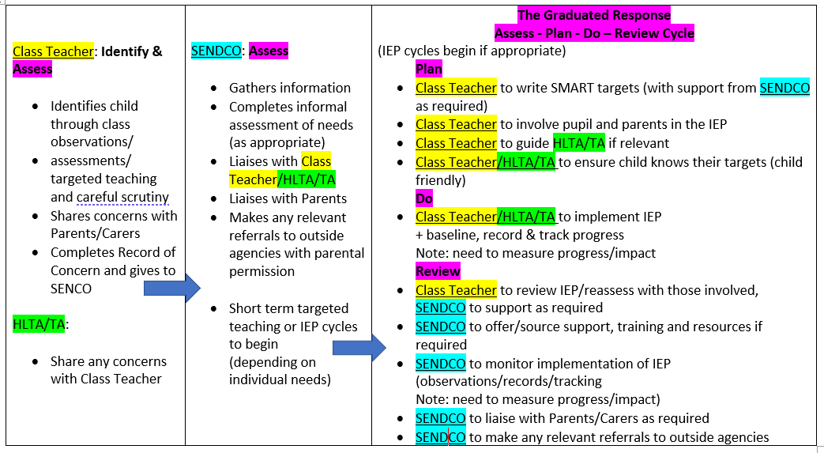

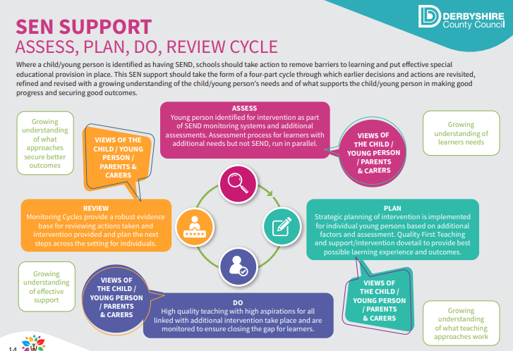
We have access to a wide range of interventions including:
- Phonics Groups
- Visual Support
- Lego Therapy
- The Incredible 5 Point Scale
- Social Stories
- Sensory resources
- Physical Literacy
- Active Hands
- Fine motor resources
- ELSA (social, emotional and mental health programme)

After two reviewed cycles of the Graduated Response, if a child has not made adequate progress and if their needs are significant and long term, we might suggest referring to the Local Authority for Inclusion funding or for an Educational Health Care Assessment, which may or may not lead to an Educational Health Care Plan.

- How we consult and involve our pupils and parents/carers
Heage Primary School has an open-door policy for parents, ensuring we are always approachable, so parents feel involved in the education of their child. As a school, we want to work closely with our parents/carers. We value the unique contributions that Parents/Carers make. We are also committed to enabling and listening to ‘pupil voice’.
- Pupils and Parents/Carers are consulted and kept fully informed. This might be with the class teacher, the SENDCO or with the Headteacher; through an informal chat, phone call or an arranged meeting. Depending on Parent’s/Carer’s availability and preference, email might also be used.
- Parents/Carers are kept up to date with their child’s progress and SEND provision in school.
- IEPs are written and reviewed in consultation with pupils and Parents/Carers.
- Any referrals to outside agencies are discussed and agreed with Parents/Carers and pupils.
- Information on our school website
- Parent’s evenings twice per year
- Parent’s and pupil’s views on Annual Review documents
- Parents/Carers and pupils are welcome to make contact or to arrange a meeting with staff to discuss concerns at any time.

- Outside agencies who might provide additional support
There are a number of Local Authority educational and NHS county services available to school, who can offer support if your child meets their service criteria. These are:
Inclusion, Support & Advisory Service (ISAT)
Educational Psychology Service (EP)
Speech and Language Therapy (SLT)
Sensory Service for children with visual (VI) or Hearing (HI) needs
Support Service for Physically Impaired (PI)
School Nurse
Community Paediatrician

We would always talk to you first and gain your permission before contacting any of these professionals.

We are not able to refer outside of the NHS for diagnoses.

- How can I let the school know I am concerned about my child’s progress in school?
If Parents/Carers have concerns relating to their child’s progress, please discuss this in the first instance with your child’s class teacher. This may result in a referral to the school SENDCO (Mrs Natalie Lane).
Parents may also contact the SENDCO (Mrs Natalie Lane) or the Headteacher (Mrs Donna Hallam) directly via the school office (01773 852188).

- How will the school let me know if they have any concerns about my child’s learning in school?
- The class teacher is regularly available to discuss your child’s progress and any concerns.
- Your child’s progress is discussed at parent’s evenings.
- The SENDCO might contact you, or you are welcome to make an appointment with the SENDCO to discuss your child’s progress and/or any concerns and worries that you have. Just ask!
- All information from outside agencies is shared with you either directly from the service or through school.
- Class teachers will consult with you regarding Individual Education Plans.

- Adaptations to the curriculum and accessibility
We make the following adaptions to ensure that pupils needs are met:
- Differentiating and adapting our curriculum and our teaching
- Adapting our resources and staffing
- Following advice from outside agencies
- Using recommended aids such as laptops, visuals, hearing and visual support aids

We are committed to making reasonable adjustments wherever possible. This may include:
- Contacting the Local Authority to see if adaptations to the building are required
- Ensuring the right equipment is available to meet every child’s needs
- Where specialist equipment is needed, contacting the Local Authority support services for advice and equipment
How accessible are your school building(s) and grounds?

We have two single-storey buildings where classrooms are based - these are fully accessible. The school car park can be accessed from the main gate up the drive. Please buzz the office to enter the car park. There is some (but limited) on-street parking and there is access on foot via the school driveway.

We have an Accessibility Plan in place. This is available on our school website.

10. Enabling pupils with SEND to engage in activities available to those in the school who do not have SEND
As an inclusive school, extra-curricular activities are accessible for our children with SEND.

Children with SEND are encouraged and expected to attend all educational visits and take part in on-site educational events. Extra staffing is available for this if required. Risk assessments are carried out as and when needed.

We pride ourselves on the experiences that we provide for all of our pupils.

11. How we support children with their emotional and social development
- All children access the Personal, Health and Social education (PHSE) aspect of our curriculum.
- Our Well-Being Lead in school is Mrs Jo McAnulty.
- Mrs Saint provides support for children with social and emotional needs. This support might be: small group and one to one work, Lego Therapy or ELSA (Emotional Literacy) sessions.
- For children with more specific difficulties, we can refer to Local Authority and NHS services if children meet service criteria.

We have a zero-tolerance approach to bullying.

- How will school evaluate the effectiveness of the SEND provision?

SENDCO monitoring
- Through monitoring the quality of provision (The Graduated Response Cycle) and impact of interventions
- Using Records of Concern to flag Pupils to the SENDCO
- Through the reviewing process of Individual Education Plan targets and progress made towards targets
- Through statutory reviews of EHCPs
- IEP tracking system
- Examples of work
- Baseline and on-going assessment
- Parents/Carers views
- Pupil’s views

13. Supporting pupils moving between phases and preparing for adulthood
We appreciate that transitions can be difficult for children with SEND. Be this starting school, internal class moves, Key Stage moves and moving schools. We pride ourselves on working closely with follow-on schools.
The SENDCO and Reception Teacher gain information prior to starting school (with Parent’s/Carer’s permission) about any children who have SEND or SEND concerns. Prospective parents of children with SEND are also welcome to arrange to meet with our SENDCO to discuss their child’s needs.
Transitions between classes within school are thoughtfully managed with Class teachers and the SENDCO passing on important information to ensure continuity of approach and provision for your child. Support such as the use of photographs is available if needed.
SEND information is passed on to Secondary Schools each year. Some of our SEND children require extra transition support and this can be arranged as required for the individual child. We are happy to work with any feeder or follow-on placement during transitions for your child.
At Heage Primary, we understand the importance of keeping in mind preparing our children for ‘life beyond Primary School’ and adulthood. We encourage independence and value children’s hopes, aspirations and ambitions.

14. What support do we have for you as a Parent/Carer of a child with SEN and/or disability?
We are here to listen and help in any way we can. This might include discussing strategies, sign posting to other organisations or referring to other services (depending on the individual circumstances).

15. How does the Governing Board support SEND children and their families?
At Heage Primary School, we have a Governor who is responsible for special educational needs. Her name is Mrs S Coope.

Her job is to meet with the SEND team regularly. In these meetings, the SEND Governor makes sure that children and families are supported by the right services in and outside of school. The SEND Governor will also visit the school, observe what happens in classrooms and meet with class teachers, support staff and children. The SENCo writes a report for every Governing body meeting. The SEN Governor shares this report with the other Governors so that the whole Governing Board is aware of how special educational needs are being supported in the school and how well this support is working. The governors will challenge, support and advise the Headteacher if appropriate provision is not being made.
16. Who are our key staff and what expertise do they have?

Mrs Donna Hallam (Headteacher) | Overall responsibility  DSL – Safeguarding pupils
Mrs Lindsey Roberts (Deputy Headteacher) | Deputy responsibility  DSL – Safeguarding pupils
Mrs Sharon Coope | SEND Governor
Mrs Natalie Lane  Special Educational Needs & Disability Coordinator (SENDCO) | Qualified SENDCO  Postgraduate in Autism  Makaton Tutor  Elklan Trained  Autism Advocate (AET)  Local SEND School Governor  SSSEN Specialist Teacher (13yrs)
Wellbeing Lead | Mrs Jo McAnulty
Mrs Amy Saint | ELSA Trained (Emotional Literacy Support Assistant) and Pastoral Support

17. Complaints about SEND provision

Please refer to our Complaints Procedure in the Policies section on our website or enquire at the school office.

18. The Local Offer

The Local Offer brings together in one place information about health, education and social care available for children and young people from birth to 25 years old who have a Special Educational Need or Disability (SEND).
It also includes different organisations, networks, support groups and charities that offer advice, activities, support and information.

You can find out what is available in our Local Authority area on the Derbyshire Local Offer: https://www.localoffer.derbyshire.gov.uk/home.aspx

19. Named contacts

Headteacher Mrs Donna Hallam 01773 852188
SENDCO Mrs Natalie Lane 01773 852188
nlane2@heage.derbyshire.sch.uk

Please note that our SENDCO currently works at Heage Primary on Wednesdays and Thursdays.
20. Glossary

ELSA Emotional Literacy Support Assistant
IEP Individual Education Plan
SEND Special Educational Needs and Disability
SENDCO Special Educational Needs Co-ordinator
SEMH Social, Emotional and Mental Health Needs
TA Teaching Assistant

