
Year 4 Curriculum – Autumn 2



Writing (2 pieces)
Purpose: Writing to inform and writing to entertain.
Grammar Coverage
Expanded noun phrases, relative clauses, commas in a list, present perfect tense, subordinating conjunctions.
Our Primary Text
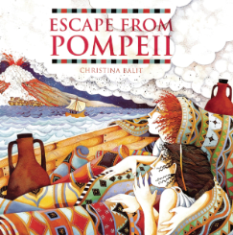
Escape from Pompeii by Christina Balit

Science
States of matter
Children learn about solids, liquids, and gases, how to group them, and how materials change state through heating and cooling. They will explore melting, freezing, evaporation, and condensation, and link these changes to the water cycle. Investigations help develop enquiry skills using tools like thermometers and observations from everyday life.


History
Romans
Children will be learning all about The Roman Empire in our History topic this term. We will be looking at where and why the Roman’s invaded and the legacy the Roman’s left behind – exploring how they changed Britain and why they left.
Within the topic we will be looking at Julius Ceaser and Boudicca.

Additional Texts/ DEAR texts
The Land of Roar by Jenny McLachlan
The Girl who stole an elephant by Nizrana Farook

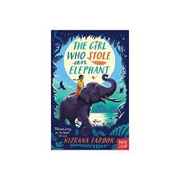

Spellings: Possessive apostrophe with singular proper nouns.
‘sure’ such as treasure, measure
Homophones.
Year 3 and 4 statutory words.

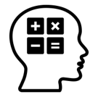
Maths
Area
Multiplication and Division

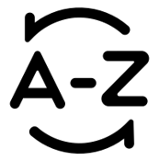



Art or D&T

Mechanical system Slingshot cars
Music
Rock and Roll
History of rock and roll
Play a rock and roll bass line





Read for pleasure

Aim to read at least 5 times a week.

Discuss what you have read and make predictions about what might happen next.
Stop and check the meaning of words.

MFL – French Language Angels
In this unit pupils will learn 10 common shapes and also the numbers 1-5. By the end of the unit pupils will be able to recognise, recall, remember and spell up to 10 shape nouns with their indefinite articles/determiners.
Computing
Purple Mash
Logo- Using text-based coding language
to control an on-screen marker.
PSHE
Our topic this term is ‘Family and Relationships/Health and Wellbeing’
Physical Education

Gymnastics – Wednesday
Invasion games- Friday

RE

I know what different people believe about God.
Spellings
Recap words from Year 1/2 common exception words
Words from the Year 3/4 common exception words

Dojo
Check Dojo for messages and an insight into what we are up to.
Practice times tables each day! 
Things you can do at home

