
Year 6 Curriculum – Summer 2



Grammar Coverage –
- Recognising formal speech.
- Using expanded noun phrases.
- Using commas to clarify meaning.
- Using hyphens to avoid ambiguity.
- Using semicolons, colons or dashes
- Using figurative language.
- Using cohesive devices.

Our Primary Stimulus

Writing


Purpose – To entertain the reader with a ghostly narrative.
To write a trip advisor review.



Science
This term’s focus is Evolution & Inheritance
- Recognise that living things evolve
- Know that fossils provide information about living things from years ago.
- Recognise that living things produce offspring of the same kind,
- Recognise variation and inherited characteristics.
- Identify how animals and plants are adapted to suit their environment which may lead to evolution.

History
We will be learning:
The Bristol Bus Boycott
- To explore the history of the Windrush generation.
- To understand the causes of the Notting Hill race riots.
- To describe what the Bristol Buses “colour bar” was.
- To understand what the Bristol Bus Boycott was.
- To understand how the boycott was resolved.

Additional Texts/ DEAR Texts

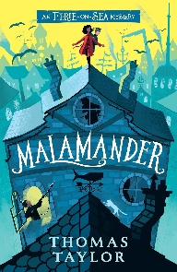
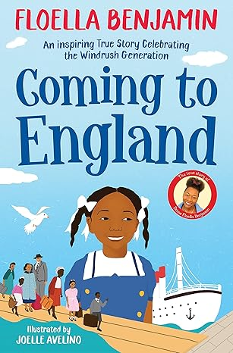



The Year 6s will be learning about maths in real-life contexts through a number of short projects where they will get to use all the skills they have learnt so far.

They will still be using an element of retrieval practice to keep what they have learnt fresh in their minds.
No Nonsense Spellings
Please see the Spelling Pathway on our website:
https://www.heage.derbyshire.sch.uk/derbyshire/primary/heage/site/pages/learning/subjects/english

Maths



D&T
- Find a suitable recipe for their course.
- Record the relevant ingredients and equipment needed.
- Follow a recipe, including using the correct quantities of each ingredient.
- Write a recipe, explaining the process taken.
- Explain where certain key foods come from before they appear on the supermarket shelf.

PSHE
- Understand feelings about money and the impact they can have.
- Explain how to safeguard money in both digital and physical environments.
- Know the money changes when moving to secondary school.
- Understand the risks of gambling.
- Explain how careers function in different settings
- Explore different career routes and their requirements.
Physical Education

PE takes place on Mondays and Wednesdays.
Monday = Mrs Roberts will be teaching Cricket
Wednesday = Mr Tomlinson will be teaching Rounders






Computing
This term we will be Understanding Databases
- Use the sort and filter functions to locate information efficiently.
- To be able to draw graphs from data in databases.
- To be able to find information in linked table databases.
Spellings for this term!
Year 5 and 6 spellings from the common exception word lists.
MFL - Chez Moi (My Home)
- Say whether they live in a house or an apartment and say where it is.
- Repeat, recognise and attempt to spell up to ten nouns (including the correct article for each) for the rooms of the house in French.
- Tell somebody in French what rooms they have or do not have in their home
Saying Goodbye!
We have a number of different transition activities planned this term, which will the help the Year 6s say goodbye to Heage and their peers.

Dojo
Check Dojo for messages and insight into what we are up to.
RE

What does it mean to be a Muslim in Britain today?
Practise your times tables!
Use Purple Mash to do the end of unit maths quizzes or the Soaring Eagles SPAG activities.

Things you can do at home

